Dear parents and carers, 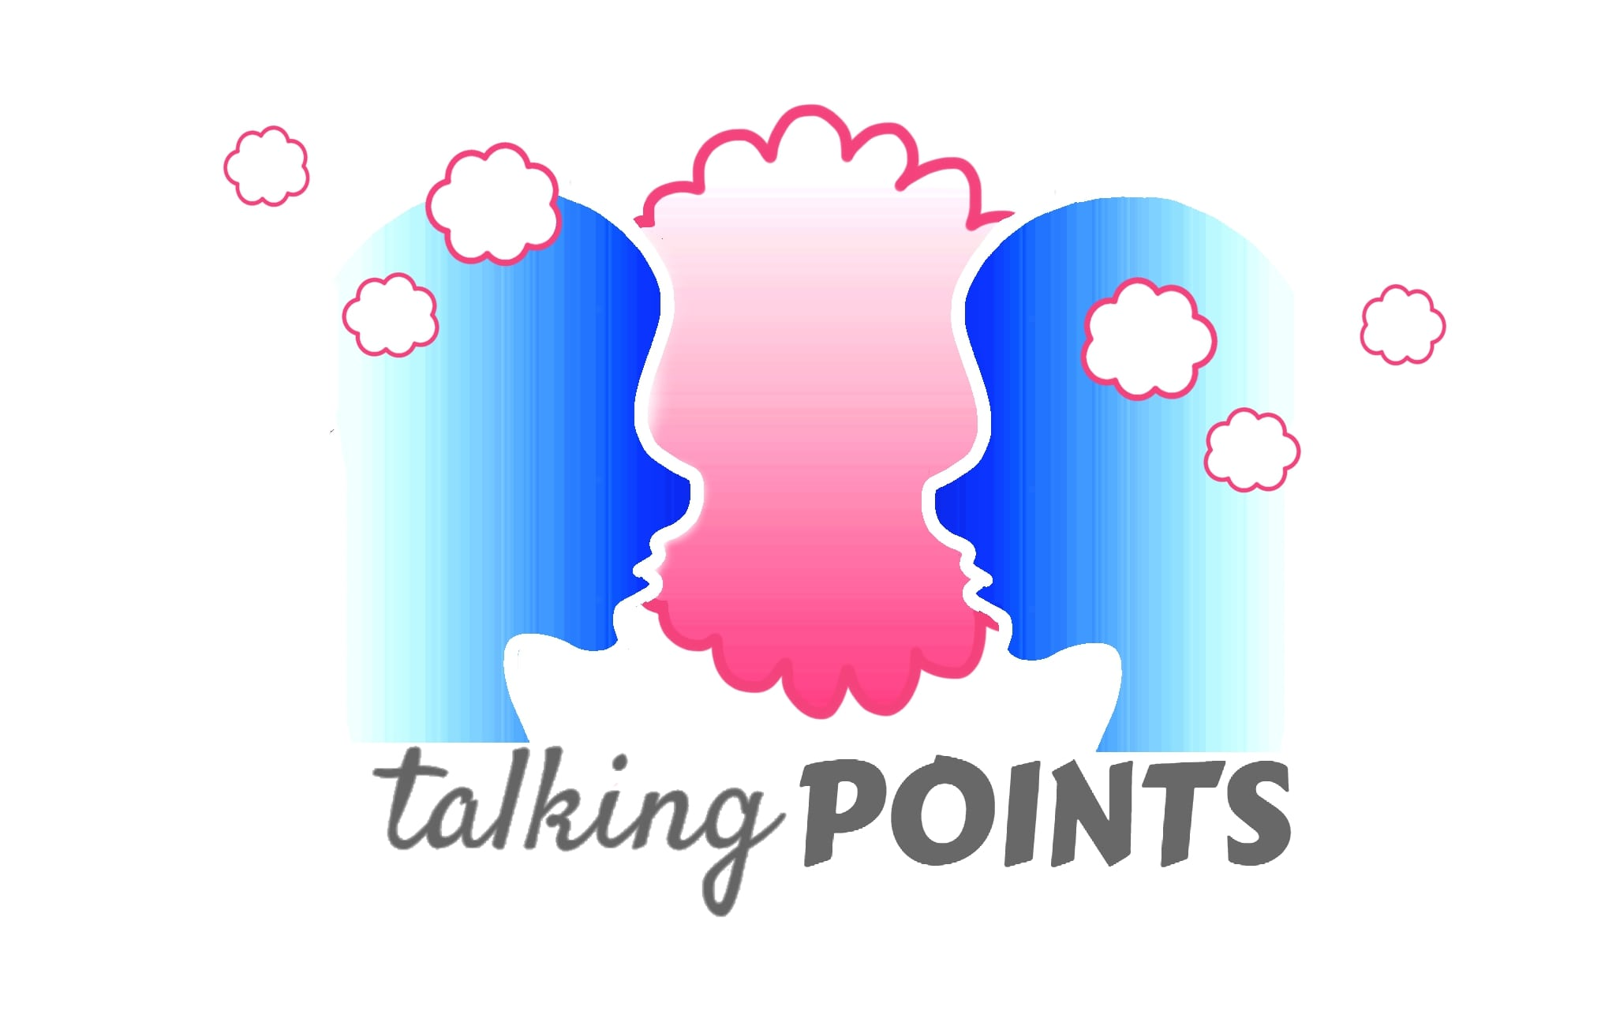
Our school is using the Talking Points schemes of work to deliver the government guidance on Health and Relationships education. It uses picture books as a starting point to get children talking about their own health and mental wellbeing as well as addressing other issues such as managing money and understanding democracy. Its aim is to develop children’s understanding of themselves, their emotions and how to deal with others. It also teaches children how to stay safe in many situations and who to speak to if they are ever worried or concerned.

Each two-week Talking Point unit has a question attached and they are listed below with the book that the children will read as a starting point.

 | Talking Point Question | Book | Author
1 | Who is in my family? | Love is a family | Roma Downey
2 | Who are my important people? | Under the love umbrella | Davina Bell
3 | What makes a person? | Whoever you are | Mem Fox
4 | What makes me happy? | Augustus and his smile | Catherine Raynor
5 | What does sad feel like? | My yellow balloon | Tiffany Papageorge
6 | Why do we have rules? | Bella's rules | Elissa Haden Guest
7 | Is it kind or unkind? | Thank you Omu | Oge Mora
8 | Is teasing ever okay? | Tease Monster | Julia Cook
9 | What should I do if I don’t like it? | No means no | Jayneen Sanders
10 | What does worry feel like? | The huge bag of worries | Virginia Ironside
11 | How do I keep safe? | No dragons for tea | Jean E Pendzewol
12 | What should I do in an emergency? | George's dragon at the firestation | Claire Freedman and Russell Julian
13 | When should I wash my hands? | I don't want to wash my hands | Tony Ross
14 | Why are teeth important? | The tooth book | Dr Seuss
15 | What should I do with money? | A chair for my mother | Vera B Williams
16 | What did I need as a baby? | The baby's catalogue | Janet and Allen Ahlberg
17 | How can I be more grown up? | Peter's chair | Ezra Jack Keats
18 | Do I have to be the best? | Giraffes can't dance | Giles Andreau

If you have any questions or concerns, please contact the school in writing.

Stephen.Tapley@william-alvey.lincs.sch.uk
Thank you for your continued support.

