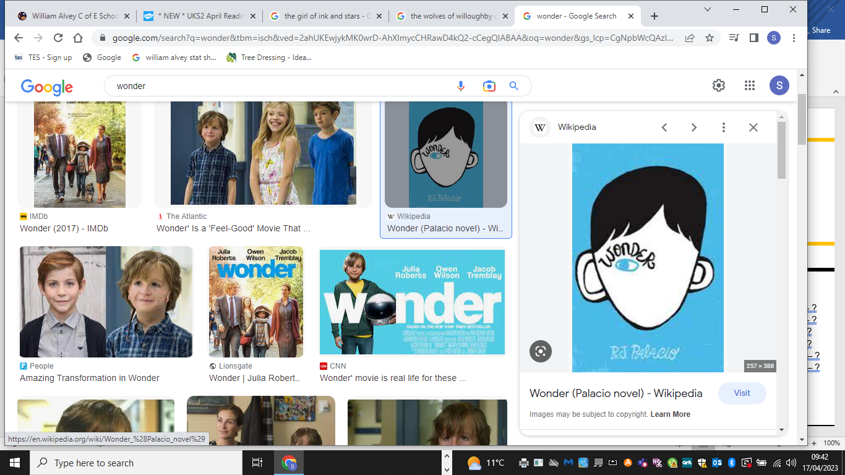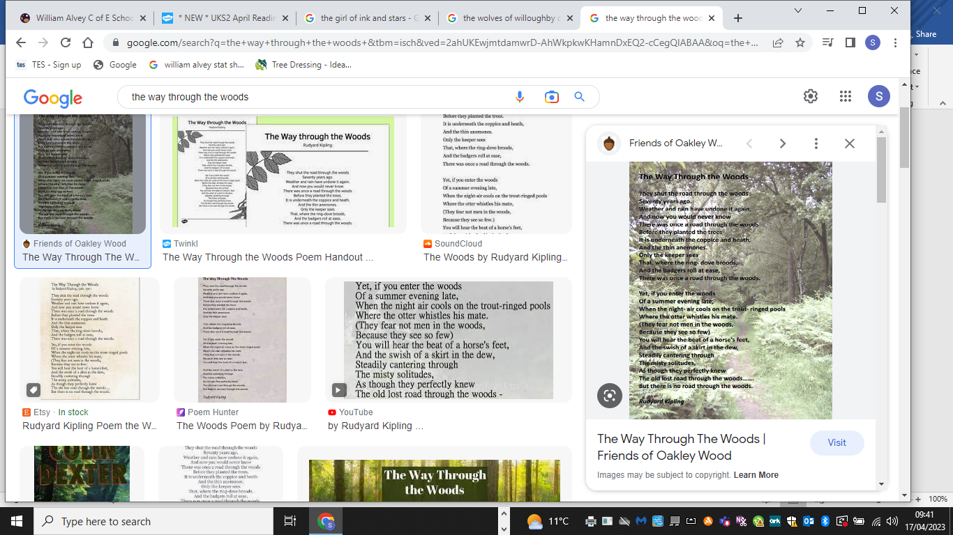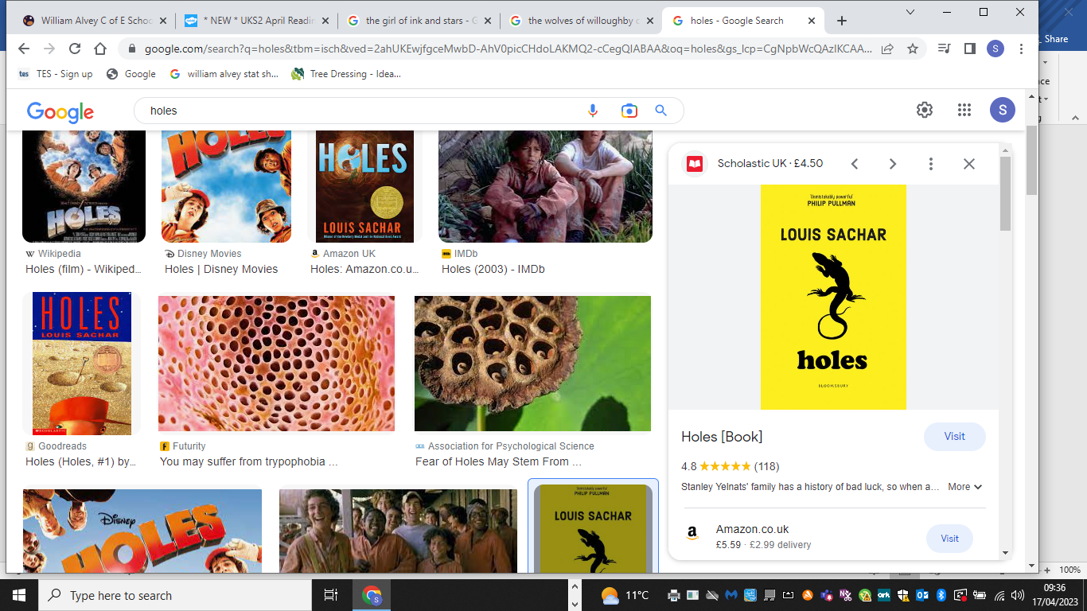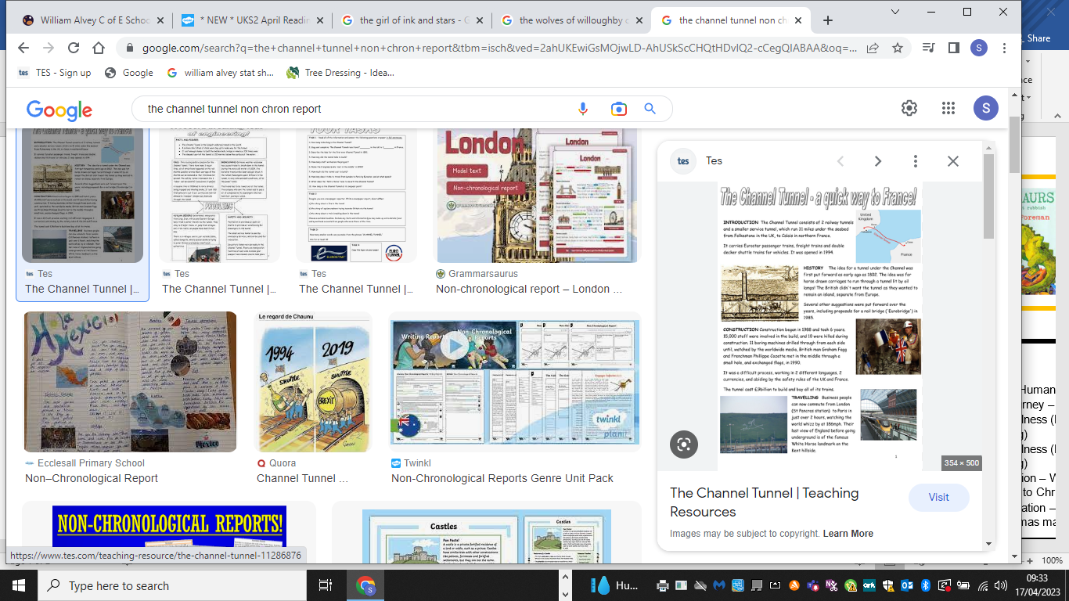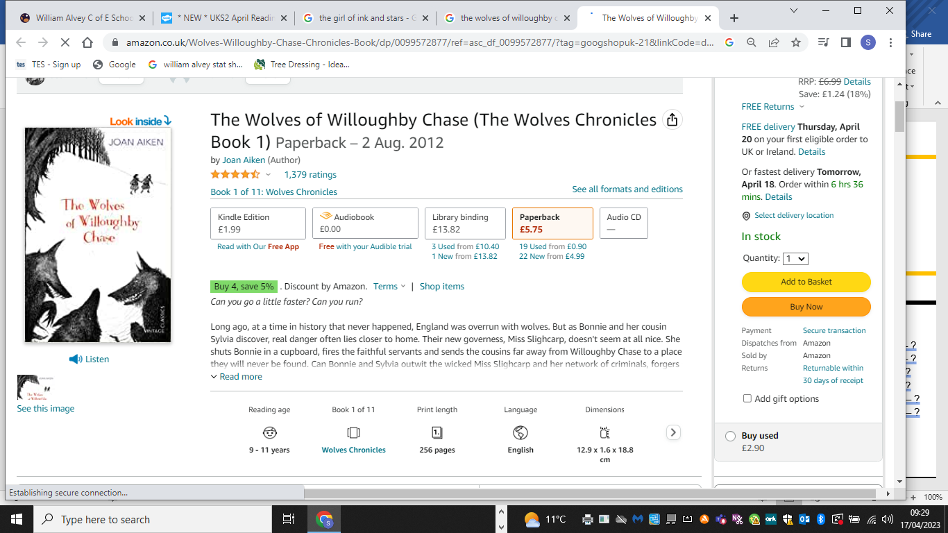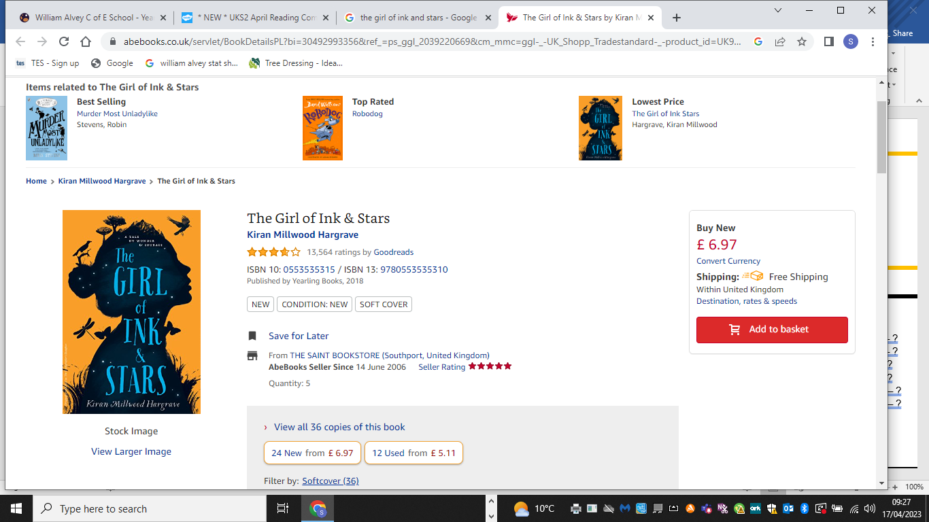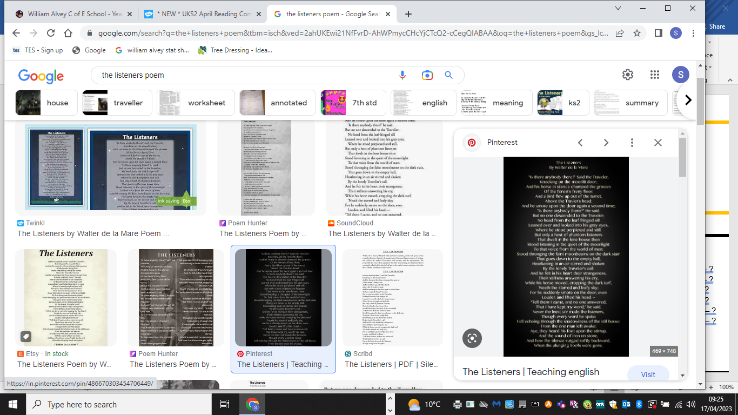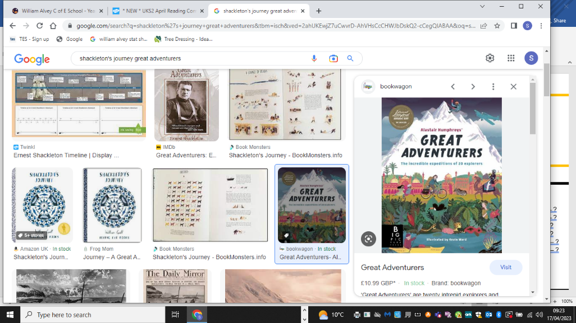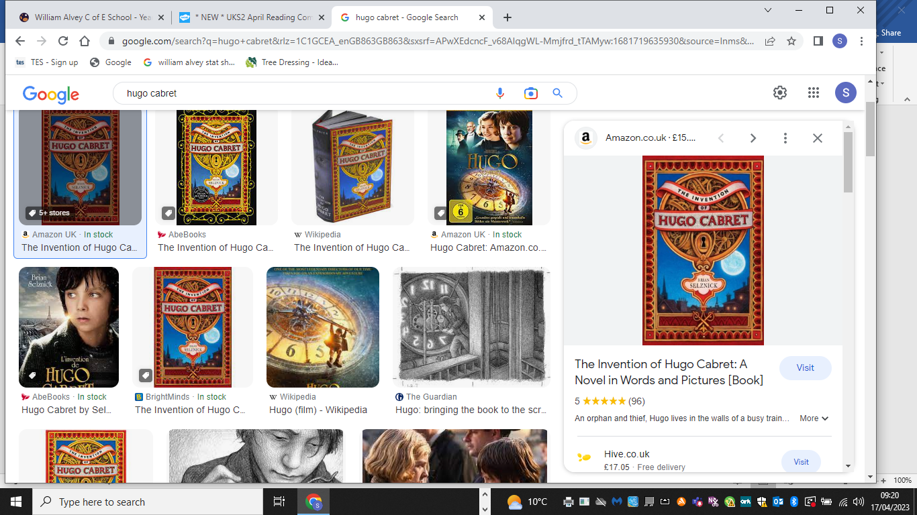

**Talk for Reading**

**Science**

* Throughout the year – Working scientifically
* Autumn 1 – Evolution & inheritance
* Autumn 2 – Animals including humans
* Spring 1 – Electricity and working scientifically
* Spring 2 – Light
* Summer 1 – All Living Things - classification

**Maths**

* Autumn 1 – Place value & four operations
* Autumn 2 – Fractions & decimals
* Spring 1 – Measurements, word problems, percentages, ratio & algebra
* Spring 2 – Area & perimeter & volume
* Summer 1 – Geometry, position & movement
* Summer 2 – Graphs & averages, negative numbers

**Talk for Writing**

* Autumn 1 – Chasing / hiding suspense
* Autumn 2 – Explanation and poetry
* Spring 1 – Flashback narrative
* Spring 2 – Discussion text and poetry
* Summer 1 – Independent writing
* Summer 2 – Auto-biography and poetry

**RE**

* Autumn 1 – Christianity, Hindu and Islam
* Autumn 2 – Inspirational People
* Spring 1 – Humanism. Spirituality
* Spring 2 – Christianity - Easter
* Summer 1 – Sikhism. Beliefs & Lifestyles
* Summer 2 – Sikhism.

**Geography**

* Autumn – To describe how locations have changed over time. Mapwork.
* Spring – To name and locate countries.
* Summer – North America

**Year 6**

**Music**

* Autumn 1 – History of music
* Autumn 2 – Classroom jazz
* Spring 1 – A new year carol
* Spring 2 – You’ve got a friend
* Summer 1 – Music and me
* Summer 2 – Singing and performing

**Design Technology**

* Spring 2 – Design and make an arched product
* Summer 2 – Program, monitor and control their products

**Computing**

* Autumn 1 – Image captures & internet safety
* Autumn 2 – Blogging
* Spring 1 – Networks & spreadsheets
* Spring 2 – Outdoor & adventure & fitness
* Summer 1 – Athletics & dance
* Summer 2 – Rounders & dance

**PE**

* Autumn 1 – Handball & swimming
* Autumn 2 – Basketball & gymnastic
* Spring 1 – Tennis & gymnastics
* Spring 2 – Outdoor & adventure & fitness
* Summer 1 – Athletics & dance
* Summer 2 – Rounders & dance

**French**

* Autumn – Pencil case & school
* Spring – Postcards & descriptions
* Summer – Animals

**History**

* Autumn 1 – Stone Age – Iron Age
* Spring 1 – World War II
* Spring 2 – World War II and our school

**Art**

* Autumn 1 – Mosaics
* Spring 1 – Paul Nash and painting
* Summer 2 – Printing